Outcome Testing
Technical Documentation
Ascot Lloyd · OTIS in production
For developers and support engineers
As of 2 October 2026 · solution version 1.0.18.0
Author: Simunye Radingwana

1. About this document
This document explains how Outcome Testing (OTIS in production) is built, so a developer or support engineer can change it, deploy it and fix it safely. For what the system does from a business point of view, read the companion Solution Guide.
Read this first: the src folder is behind the live environments. src/Other/Solution.xml says 1.0.6.0, while TEST and PROD run 1.0.18.0. Some live components are not yet in src/: the al_ProductName environment variable, the al_ReconcileCaseAccess API, the case access columns and plug-ins, and several newer columns. Run scripts/round-trip-src.ps1 against DEV before relying on src/ as a complete picture. Where this document describes something that exists only live, it says so.

2. Architecture
OTIS runs entirely on Microsoft Power Platform. Two front ends share one Dataverse database, and every business rule runs once, on the server, in C# plug-ins.
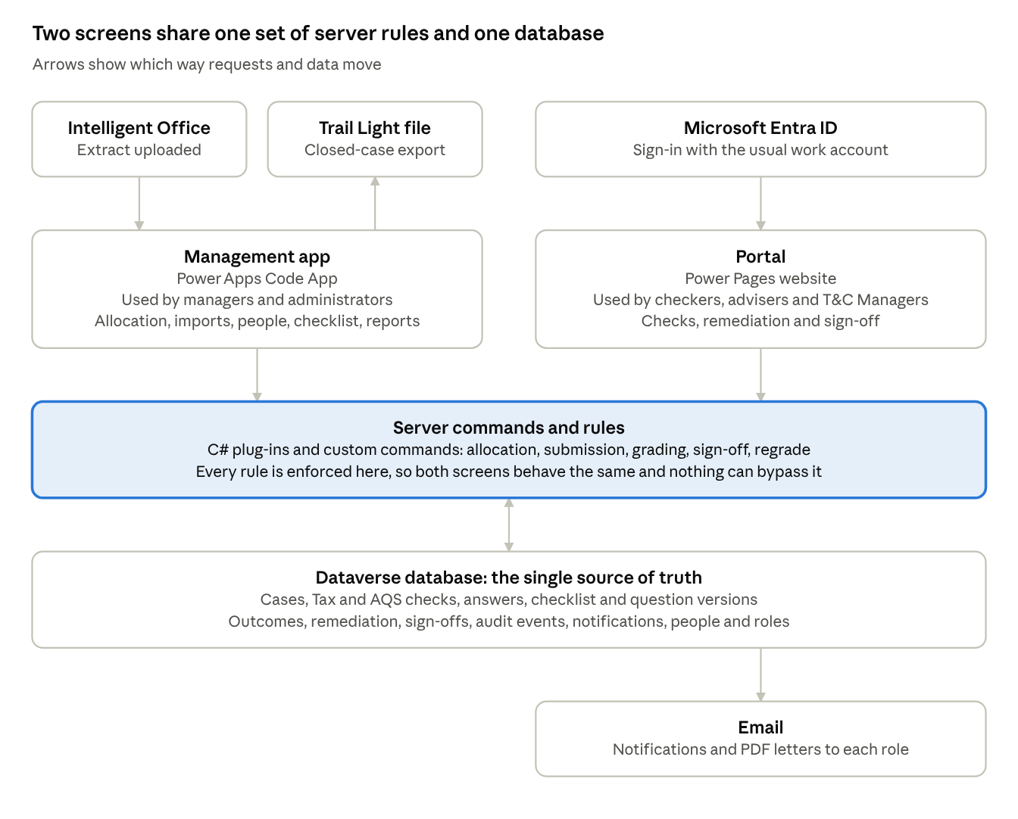
Figure 1. Components and how they connect

Design principles
- Dataverse is the system of record. Client documents stay in Intelligent Office and are referenced, not copied.
- Rules live on the server. Each action is a Custom API, and table plug-ins guard direct writes. The front ends only offer what the server would accept; they never enforce on their own.
- Nothing is overwritten or deleted. Initial and final outcomes are stored side by side. Checklist content is dated in and out, never deleted. A submitted review always reads as of its submission day.
- Every command is audited and idempotent. Commands take an idempotency key and write one immutable al_auditevent row. A replay returns the original result instead of acting twice.
- Front ends split by persona, not by feature. Managers and administrators use the Code App; checkers, advisers and T&C Managers use the portal.

3. Repository layout
Path | Contents
src/ | Unpacked Dataverse solution (tables, roles, Custom APIs, steps, portal components, Code App package). Packed in full.
plugins/OutcomeTesting.Plugins/ | Plug-in assembly (C#, net462, strong-named). All server-side rules.
plugins/OutcomeTesting.Plugins.Tests/ | xUnit tests with fake organisation service and execution context.
plugins/OutcomeTesting.Registration/ | Command-line registration and support tool (net8.0), about 96 verbs.
plugins/customapi/ | Custom API contracts (*.customapi.json) used to register APIs.
app/ | Power Apps Code App (React 19, TypeScript, Vite). Kept outside src/.
powerpages/ | Power Pages site metadata, plus the portal deploy and check scripts.
scripts/ | Import-Solution.ps1 and round-trip-src.ps1.
brand/ | Ascot Lloyd brand assets. The only source of colours and fonts.
knowledge/ | Domain context, requirements index, decision log (AD-/OD- records).
docs/deployment/ | Dated record of every deployment and how it was verified.
docs/reference/ | Business requirements, the checker checklist, the portal access runbook.

4. Data model
All custom tables use the al_ prefix. A case holds one review per check (Tax or AQS), and each review holds one response per question version it answered. Case tables are user-owned so they can be allocated; configuration tables are organisation-owned.
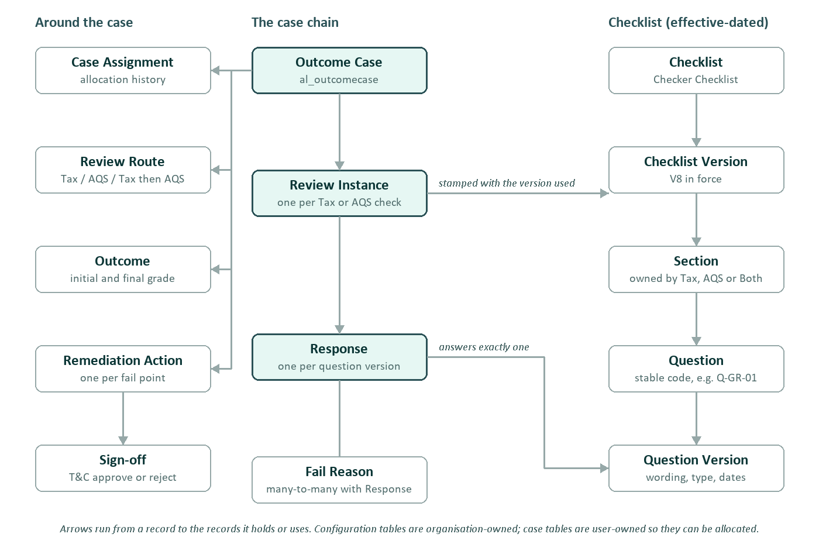
Figure 2. Core tables and relationships

Case tables
Table | Purpose | Notable columns
al_OutcomeCase | One case imported from Intelligent Office | Alternate key al_casereference (IO TaskID); al_casestatus; al_reviewrouteid; al_previouscaseid; IO columns al_Io*. Live only: six case access columns and al_vulnerableclientid.
al_CaseAssignment | Allocation history | al_assignedcontactid, al_IsActive, al_ReleasedOn
al_ReviewInstance | One Tax or AQS check | al_reviewtype (Tax/AQS), al_reviewstatus (Assigned, In Progress, Submitted), al_checklistversionid, request columns al_submitrequested, al_answerrequest
al_Response | One answer to one question version | Typed answer columns (al_AnswerText, al_AnswerChoice, al_AnswerChoices, al_AnswerDate, al_AnswerRichText); N:N to al_FailReason
al_Outcome | Grade for a review or case | al_InitialOutcome, al_FinalOutcome, al_RegradeReason, fail accountability flags
al_RemediationAction | An action raised by a non-pass outcome | al_actionstatus (Open, In Progress, Completed), al_adviserresponse, al_RecheckRequired, request column al_completerequested
al_Signoff | T&C Manager decision | Approved or Rejected

Checklist tables
Checklist → Checklist Version → Section → Question → Question Version, with delete restricted at every level. Versions and question versions carry al_EffectiveFrom and al_EffectiveTo. Sections carry an owner (Tax, AQS or Both), al_IsOptional and al_IsConditional. Question versions carry al_ResponseType and al_IsMandatory.
Eight question codes are referenced by name in the plug-ins (for example Q-GR-01, the AQS grade, and Q-GR-02, the root cause), and the retire commands refuse them. Library successors are coded QV-<questionid>-vN.

Reference, security and operations tables
Table | Purpose
al_ReviewRoute | Allowed routes: Tax only, AQS only, Tax then AQS
al_FailReason | Fail reasons, with a category
al_ListOption | Case-header dropdown options as rows, with legacy values and effective dates
al_AdviserMapping | Adviser email → T&C Manager. Drives routing, the sign-off and regrade gates, and case access
al_NotificationTemplate | Subject and body of one email letter; overrides the compiled default
al_Role, al_UserRoleMapping, al_PagePermission | Application role registry, role grants by work email, and per-role access levels (None, View, Edit, Manage)
al_AuditEvent | Immutable record of every command, keyed by idempotency key
al_ImportBatch, al_ImportException | One upload of the IO extract, and its rejected rows
al_ExportBatch, al_ExportRecord | One Trail Light export and its snapshot rows
al_Notification | Email outbox: event, status (Pending, Sent, Failed), PDF attachment

People are contact rows keyed on work email (emailaddress1). The contact table also carries the portal request columns (section 6) and al_StaffCode.

5. Case lifecycle
CaseLifecycle.cs defines the statuses and the allowed moves. Every write to al_casestatus is checked, by the commands and by CaseStatusGuardPlugin on the table itself. The Code App offers only moves the server would accept.
From | Allowed next statuses
Imported | Validation Failed, Ready for Allocation, No Check Required
Validation Failed | Ready for Allocation, Closed, No Check Required
Ready for Allocation | Queued, No Check Required
Queued | Assigned, No Check Required
Assigned | Review In Progress, Queued, No Check Required
Review In Progress | Submitted, Queued, Assigned, No Check Required
Submitted | Awaiting Remediation, Closed
Awaiting Remediation | Remediation In Progress
Remediation In Progress | Awaiting Sign-off
Awaiting Sign-off | Awaiting Recheck, Awaiting Remediation, Queued
Awaiting Recheck | Closed
Closed, No Check Required | None (final)

Grades: Pass, Pass with issues, Insufficient evidence, Potential harm. The initial grade uses option values 120910700 to 703 and the final grade 120910710 to 713. The effective grade is the final one if set, otherwise the initial one (Outcomes.cs). al_iooutcome is Intelligent Office's own value, not an OTIS grade.

6. Server layer

6.1 Custom APIs
Each API al_X is implemented by XPlugin in the plug-in assembly. The Code App calls them directly.
Area | APIs
Case work | al_AssignCase, al_SubmitReview, al_UpdateCaseDetails, al_CompleteRemediation, al_SignOffRemediation, al_RegradeCase, al_SetFailAccountability
Intake and export | al_ImportCases, al_ResolveImportException, al_CreateExportBatch, al_GenerateExport
Checklist admin | al_AddSection, al_UpdateSection, al_RetireSection, al_AddQuestion, al_MoveQuestion, al_RetireQuestion, al_RetireAndSucceedQuestion
Security and people | al_CreateRole, al_UpdateRole, al_AssignUserRole, al_SetRoleAssignmentActive, al_AdoptRoleAssignment, al_SetPagePermission, al_SetPermissionRuleActive, al_GetMyRoles, al_GetRoleHolders, al_CreateUser, al_UpdateUser, al_SetUserActive
Notifications | al_DrainNotifications (re-sends Pending or Failed rows; default 50, maximum 250)
Live only | al_ReconcileCaseAccess (needs permission.manage)

Commands fail with a prefixed message the front ends map to plain text: PRECONDITION: (a business rule is not met, with the detail), UNAUTHORIZED: (the caller may not do this), and CONFLICT: (the record changed since it was read).

6.2 Table plug-in steps
Synchronous unless stated. Pre-operation steps guard; post-operation steps apply consequences.
Plug-in | Trigger | What it does
ResponseGuardPlugin | al_response create/update, fail reason associate (pre) | Enforces the submission lock and answer shape
ResponseProgressPlugin | al_response create/update (post) | First answer moves the review to In Progress
RemediationResponseGuardPlugin | al_remediationaction update (pre) | Locks the adviser response once Completed
SignoffGuardPlugin | al_signoff create (pre) | Validates the sign-off
SignoffProgressPlugin | al_signoff create (post) | Recheck, close or return to adviser; queues emails
CaseStatusGuardPlugin | al_outcomecase update of status (pre) | Enforces the lifecycle on direct writes
ClaimCasePlugin | al_caseassignment create (pre) | Portal self-claim: stamps the assignment, creates the review
NotificationTemplateGuardPlugin | al_notificationtemplate create/update (pre) | Refuses broken templates, sanitises HTML
NotificationEmitterPlugin | al_caseassignment, al_remediationaction create (post) | Queues allocation and remediation emails
NotificationDrainPlugin | al_notification create (post, async) | Sends the email as the service mailbox account
CaseAccessPlugin (live) | case, review, remediation writes (post) | Recomputes who may see the case
CaseAccessGuardPlugin (live) | case access columns (pre) | Only the reconciler may write them
AqsQueueMembershipPlugin (live) | associate/disassociate | Keeps AQS reviewers linked to the AQS queue account

6.3 Portal request columns
Power Pages cannot call Custom APIs. Instead, a portal page PATCHes one column over the portal Web API (/_api/), and a synchronous plug-in on that column runs the command as if it had been called. Contact columns are written on the signed-in user's own row, which their Self-scoped permission allows. Webapi/contact/fields whitelists exactly these contact columns.
Column | Plug-in | Action
contact.al_claimrequest | ClaimRequestPlugin | Checker picks up a queued case
contact.al_signoffrequest | SignoffRequestPlugin | T&C sign-off; signatory must be the mapped T&C Manager
contact.al_regraderequest | RegradeRequestPlugin | Regrade, with the same mapping gate
contact.al_caseheaderrequest | CaseHeaderRequestPlugin | Tax team edits case header fields
contact.al_accountabilityrequest | AccountabilityRequestPlugin | Records who carries a fail
contact.al_remedialactionsrequest (live) | RemedialActionsRequestPlugin | Checker writes remedial actions
al_reviewinstance.al_submitrequested | SubmitRequestPlugin | Submits the review (same logic as al_SubmitReview)
al_reviewinstance.al_answerrequest | AnswerRequestPlugin | Saves answers
al_remediationaction.al_completerequested | CompleteRequestPlugin | Adviser completes an action

7. Notifications
All email is sent from Dataverse server-side email. There is no Power Automate.
- Queue. The command that causes an email writes an al_notification row (Pending) in the same transaction, so an email is never sent for a change that rolled back. Repeats are idempotent.
- Compose. The body comes from the active al_notificationtemplate row for that template code, or from the compiled default in NotificationTemplates.cs. Tokens are HTML-escaped. Links use the al_PortalBaseUrl environment variable.
- Attach. PDFs are built when the row is queued, by the in-house PdfWriter: one per submitted check, and a remediation PDF once any action is completed.
- Send. The asynchronous NotificationDrainPlugin creates an email activity with its attachments and sends it. The row becomes Sent, or Failed with a reason. al_DrainNotifications retries a backlog.
Template codes: ALLOCATION, ALLOCATION-NO-LINK, REVIEW-SUBMITTED, REMEDIATION-PASS-WITH-ISSUES, REMEDIATION-HARM, REMEDIATION-OTHER, CASE-PASSED, SIGNOFF-APPROVED-RECHECK, SIGNOFF-APPROVED-CLOSED, SIGNOFF-APPROVED-CLOSED-NOGRADE, SIGNOFF-REJECTED, RECHECK-DUE, SIGNOFF-DUE.
"Sent" on the outbox row means handed to Dataverse email. Delivery depends on the sending mailbox being approved and synchronised; check the email activity's status when a message does not arrive.

8. Security model
Layer | How it works
Dataverse security roles | "<Product> App User" and "<Product> App Admin" ship in the solution; "<Product> Team Manager" is created by the grantteamsecurity verb. Every holder also needs Basic User.
Teams and queue | Owner teams "<Product> - Tax Team" and "<Product> - AQS Team", and an account "<Product> - AQS Team" for the AQS queue. Created by ensureaccessprincipals and found by name.
Portal web roles | Tax Reviewer, AQS Reviewer, Adviser Remediation, Planner, T&C Supervisor, Tax Team Manager, AQS Team Manager, <Product> Manager, Portal Administrator, plus the built-in Administrators and Authenticated Users. Names are prefixed AL Portal - .
Portal table permissions | 44 permissions. Case data is Contact-scoped through the case access columns; the AQS queue is Account-scoped; child tables use Parent scope; reference tables are Global read. Deployed with restoretablepermissions, not pac.
Code App permissions | A person's roles are the union of their web roles and active al_userrolemapping rows. al_pagepermission maps each role to an access level per resource key (pages such as page.cases, capabilities such as command.assign). Routes are wrapped in <RequirePermission>. System Administrators bypass the gate.
Case access (live) | CaseAccess.cs decides who should see a case; CaseAccessReconciler writes the access columns and team shares. An adviser sees a case only once it has a remedial action, is at Awaiting Remediation or later, and owes no unsubmitted review.

Product name. Plug-ins and the Code App read the environment variable al_ProductName (default "Outcome Testing"; "OTIS" in PROD). Portal templates read the site setting OT/ProductName. Labels fixed in the package (solution, roles, app, site) are rewritten for PROD with the brandpackage verb.

9. Management app (Code App)
Item | Detail
Structure | app/src/app (router, navigation, permissions, product name), features/ (admin, cases, dashboard, imports, people, remediation, reports, reviews), services/ (OData reads, one command wrapper per Custom API), generated/ (from the pa CLI)
Data access | commandClient.ts calls Custom APIs through @microsoft/power-apps, using the generated dataSourcesInfo.ts. Tables are read through generated services and OData.
Routes | /, /cases and case subpages (allocation, remediation, recheck, audit), /reviews/:id/tax|aqs, /imports, /reports, /exports, /people, /admin/* (questions, advisers, lists, templates, users, security)
Commands | npm run build (tsc -b then vite build), npm test (Vitest), npm run e2e (Playwright; npm run e2e:auth captures sign-in), npm run lint
Deploy | npm run build, then npx pa app push. Push updates DEV only; TEST and PROD receive the app inside the solution.

Regenerating data sources drops parameters that were declared by hand (currently StaffCode on al_UpdateUser). A guard test fails if that happens.

10. Portal (Power Pages)
The site uses the Enhanced data model. Pages read with Liquid {% fetchxml %} and write by PATCHing the portal Web API with the anti-forgery token. Sign-in is Microsoft Entra only; registration and local login are off.
Template | Purpose
OT Layout, OT Home | Page shell; landing page with outcome cards
OT My Work | The signed-in person's own reviews and actions
OT Case List, OT Case Detail | Worklist with server-side search; case header and progress
OT Review Detail | The checklist form, built from the review's stamped checklist version
OT Review List, OT Tax Reviews, OT AQS Reviews | Shared Tax/AQS queue and worklist
OT Remediation | Adviser and T&C Manager worklist, with working-day ageing
OT Tax Notes, OT AQS Notes, OT Checklist Items | Read-only check notes and IO checklist ticks
OT Answer Options, OT Outcome Label, OT Status Badge, OT Empty State | Shared includes
OT Access Denied, OT Not Found | Error pages

Deploying the portal
powerpages/Deploy-Portal.ps1 -OrgUrl <url> runs the check scripts, uploads with pac pages upload --modelVersion Enhanced, writes table permissions with restoretablepermissions, and verifies by query. One template can be pushed with the pushwebtemplate verb.
- Check-PortalSecurity.ps1: no anonymous grants, page rules, read-only Global scope, sign-in settings, read permission for every queried table.
- Check-PortalTemplates.ps1: static Liquid checks, including question codes against knowledge/checklist-v8.md.
- Check-ComponentIds.ps1: no two components share an id.
powerpages/ is hand-authored, not a mirror of DEV. An upload pushes local files over DEV even if DEV is newer. Download or diff first.

11. Intake and export

Import
- The Code App converts the Intelligent Office workbook to CSV and calls al_ImportCases. ImportRules.cs is the parser and the authority on format.
- Up to 1,000 rows per call. Rows with a missing or duplicated TaskID are rejected; references already held are skipped. New cases start at Imported.
- The route comes from the checklist items: "Tax Check", "Tax" or "Trust Documentation Check" means a Tax check is required.
- Each upload is an al_importbatch; rejected rows are al_importexception rows, closed with al_ResolveImportException.
- Key IO columns: TaskID (case reference), ClientRef, Client, AdviserName, AdviserEmail, AssignedBy (paraplanner), Status, Outcome, ChecklistItem1 to 10.

Trail Light export
- al_CreateExportBatch opens a draft batch; al_GenerateExport snapshots each Closed case into al_exportrecord. Both need export.generate and are idempotent per batch.
- The column order (19 columns) is owned by app/src/features/reports/trailLight.ts. The file is named DFALIN1_outcometesting_yyyy_mm_dd; the receiving system depends on that name.
- Export is manual and on demand. There is no SFTP.

12. Registration tool
plugins/OutcomeTesting.Registration is a .NET 8 command-line tool for everything pac cannot do. Run the built exe with $env:DOTNET_ROLL_FORWARD='Major'. Verbs that change data require --confirm <orgUrl>. Run one instance at a time: a second instance waits forever at "Connecting".
Area | Main verbs
Plug-ins | registerall, registertype, registerstep, setstepstate, verifysteps, pushassembly, addcomponent, metadatamembership
Schema | add*column, addoptionvalue, setoptionlabel, setcascade, setchangetracking
Security and people | grantsecurity, grantteamsecurity, ensureaccessprincipals, grantapprole, setpagepermission, seedwebroles, bindidentity, setsecuritystamp, enableportallogin, onboardpeople, reconcileaccess
Portal | pushwebtemplate, pushwebfile, restoretablepermissions, setsitesetting
Data | importseed, seedlistoptions, seednotificationtemplates, importcases, routecase, queueroutedcases
Diagnostics | fetch, webapi, webapimany, callapi, settracelog, renderpdf, verify*
Packaging | brandpackage <in.zip> <out.zip> <product>

13. Build, test and release

13.1 Plug-ins
$env:DOTNET_ROLL_FORWARD='Major'
dotnet test plugins/OutcomeTesting.Plugins.Tests
dotnet build plugins/OutcomeTesting.Plugins -c Release
# then push the Release build to DEV with the pushassembly verb
pushassembly uploads bin/Release as it is, without building. Always build Release first and check the byte count it reports. Last recorded test run: 1,765 of 1,765 plug-in tests and 1,242 of 1,242 Code App tests passing, with tsc -b clean (1 October 2026).

13.2 Environments
Environment | Org | State
DEV (Env_AQ_Dev) | org0b075da8.crm11.dynamics.com | Unmanaged; the only place changes are made
TEST (Env_AQ_Test) | org37995f36.crm11.dynamics.com | Managed 1.0.18.0; portal outcometestingtest.powerappsportals.com
PROD | org3461d426.crm11.dynamics.com | Managed "OTIS" 1.0.18.0; portal otis-ascotlloyd.powerappsportals.com

13.3 Releasing a solution
- Finish and verify the change in DEV.
- Export OutcomeTesting from DEV as managed. Keep src/ current with scripts/round-trip-src.ps1.
- For PROD, rebrand the package: brandpackage <in.zip> <out.zip> OTIS.
- Import with scripts/Import-Solution.ps1 -Environment <url> -ZipFile <zip> -Managed. It always passes --activate-plugins and then runs verifysteps.
- Read the solution version back from the target. The import script can report success when pac never connected.
- Diff portal templates against the repo. A template ever pushed directly to an environment hides later managed imports of it; re-push it.
- Seed configuration data if it changed (list options, templates, mappings). It is not in the solution.
Set per environment, never shipped: al_PortalBaseUrl (host only), al_ProductName and OT/ProductName values, the portal's Entra sign-in settings and app registration, site visibility, sending mailbox approval, and people, role and adviser mappings.
Changes to PROD are approved and made by the system owner.

14. Support guide

14.1 Known pitfalls
Symptom | Cause | What to do
Rules stop applying after an import, but screens look fine | Import without --activate-plugins disables plug-in steps | Use Import-Solution.ps1; check with verifysteps; re-enable with setstepstate
Deployed plug-in fix has no effect | pushassembly sent an old Release build | Build -c Release, push again, compare the byte count
Code App change not visible | pa app push sent an old dist/, or the short play URL serves the old bundle | Run npm run build first; open the /app/ URL with sourcetime printed by the push
A Code App command ignores a parameter | The parameter is missing from dataSourcesInfo.ts | Declare it and keep its guard test
Type errors not reported | tsc --noEmit checks nothing in app/ | Use tsc -b
Portal page shows stale data | Liquid fetch cache | The same URL with an upper-case GUID reads fresh; the cache clears itself
SecLib::CheckPrivilege error | An OTIS role without Basic User | Add Basic User
Allocation refused naming the assignee | Assignee has no app role | Grant the matching checker role
Sign-off or regrade refused | Adviser has no T&C Manager mapping | Add the adviser mapping
Portal user refused at the site | Site visibility (Private site) | Add them, or their Entra group, under Manage access. Test with a non-admin account
Email not received | Mailbox not approved or not synchronising | Check the email activity status and the mailbox in the target environment

14.2 Known gaps
- src/ is at 1.0.6.0 while live is 1.0.18.0. Round-trip DEV into src/ before the next managed export from source.
- webrole.yml lacks the Tax Team Manager and AQS Team Manager web roles that the code uses.
- The al_CreateUser, al_UpdateUser and al_SetUserActive descriptions still mention the retired al_user table; the code writes to contact.
- Import-Solution.ps1 verifies steps against the step list in src/, which is incomplete until the round-trip is done.
- PROD go-live items still open: mailbox approval, sharing the Code App, site visibility, one end-to-end case, auditing and plug-in trace logging.

